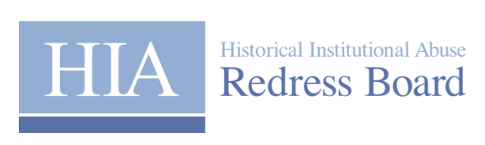

**Historical Institutional Abuse Redress Board (Applications and Appeals) Rules (Northern Ireland) 2020**

**Expenses Claim Form for Unrepresented Applicants**

(Please refer to the Applicants Costs and Expenses Protocol which can be found at <https://www.hiaredressni.uk/publications/costs-and-expenses-protocol> prior to completing this form)**.**

**SECTION 1**

|  |  |
| --- | --- |
| **Applicant Name** |  |
| **Redress Board Ref No** |  |
| **Address** |  |
| **Phone No:** |  |
| **Email Address:** |  |
| **BACS details**  **(Sort Code and Bank Account and address of bank)** |  |

**SECTION 2**

The Redress Board will reimburse the costs of obtaining certified proofs of identity, for example a birth or death certificate, where these have been obtained for the sole purpose of making an application to the Redress Board.

|  |  |  |
| --- | --- | --- |
| **Expenses for applicants obtaining proofs of identity** | | |
| Description of Expense | Amount Claimed | Receipts attached (Y/N) |
|  |  |  |
|  |  |  |
|  |  |  |

**SECTION 3**

Only complete this section if you have been required to attend an oral hearing.

|  |  |  |  |
| --- | --- | --- | --- |
| **Travel Expenses to attend an Oral Hearing (if applicable)** | | | |
| Date of hearing | Name of  representative | Journey (from – to) | Miles |
|  |  |  |  |
|  |  |  |  |
|  |  |  |  |

|  |  |  |  |  |
| --- | --- | --- | --- | --- |
| **Loss of earnings incurred while attending an Oral Hearing (if applicable)** | | | | |
| Date of hearing | Name of  representative | Hours attended (from - to) | Cost | Evidence attached (Y/N) |
|  |  |  |  |  |
|  |  |  |  |  |

|  |  |  |  |  |
| --- | --- | --- | --- | --- |
| **Child care costs incurred while attending an Oral Hearing (if applicable)** | | | | |
| Date of hearing | Name of  representative | Hours attended (from - to) | Cost | Receipts attached (Y/N) |
|  |  |  |  |  |
|  |  |  |  |  |

Please return his form by email to [admin@hiaredressni.uk](mailto:admin@hiaredressni.uk) or by post to **PO Box 2266, BELFAST, BT1 9ZP**